CASE STUDY 1: Population Growth Analysis Using Numerical Methods

Scenario: A local government wants to analyze how population changes over time. However, they only have yearly population data, not a continuous function.

Given Data
Year | Population
2020 | 10,000
2021 | 10,800
2022 | 11,900
2023 | 13,200
2024 | 14,800

Expected Outputs
- Table of derivatives
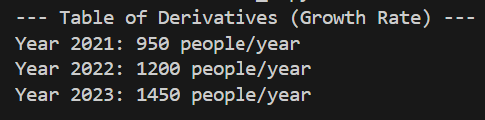

- Integrated total population estimate
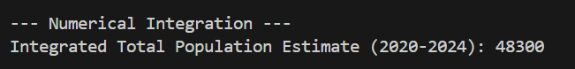

- Graphs
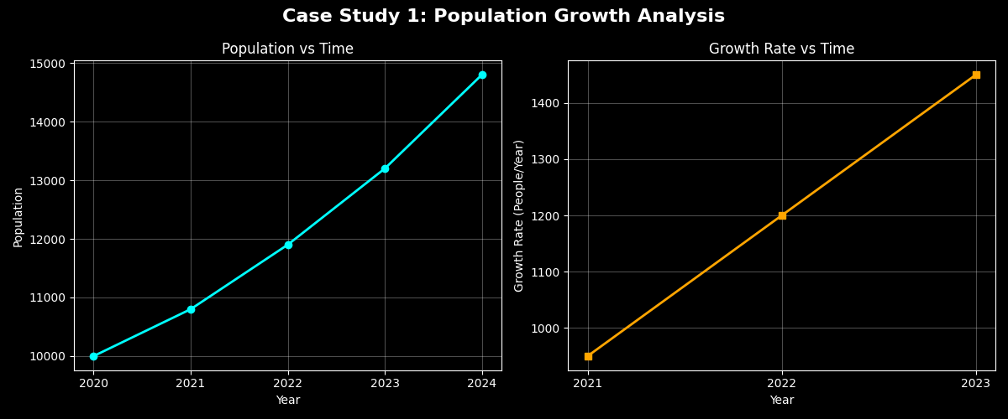

- Short analysis report
- Acceleration: The central difference calculations prove the population is not just growing, but accelerating. The rate of change increased linearly, peaking at 1,450 new people/year in 2023.
- Accumulation: The numerical integration (Trapezoidal Rule) estimates a total accumulated population area of 48,300 over the 5-year block, quantifying the massive scale of the growth.
- Trend & Prediction: Because the acceleration is constant (+250 people/year), the overall population growth is exponential. Following this trend, we project the population will reach roughly 16,500 by 2025.

CODE
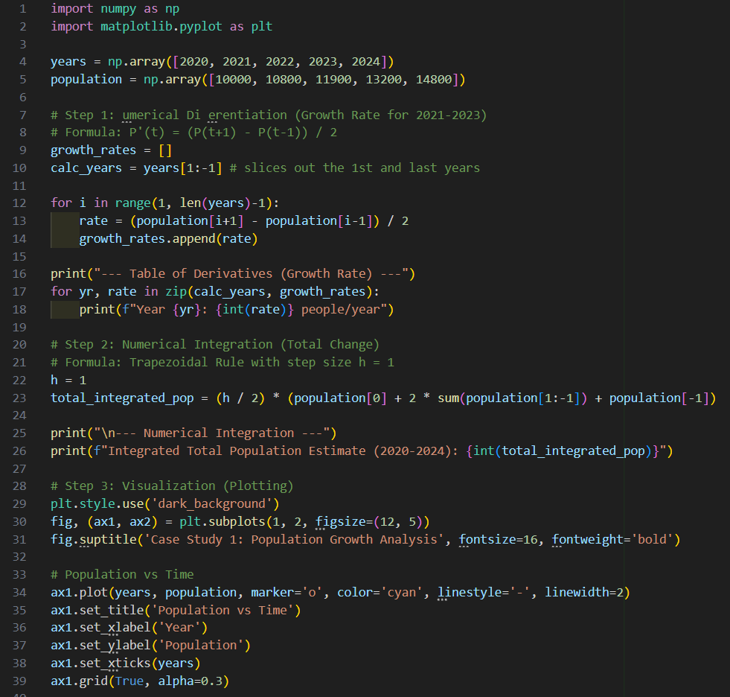
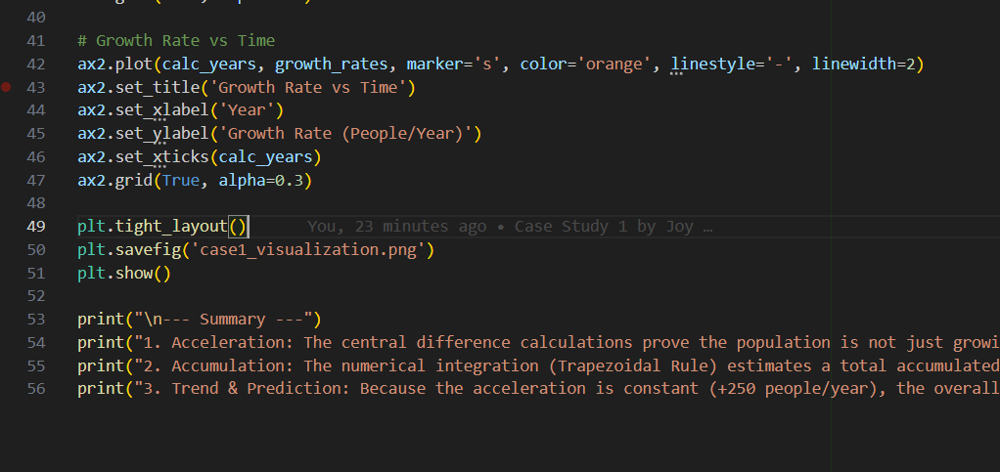

CASE STUDY 2: Population Growth Analysis Using Numerical Methods

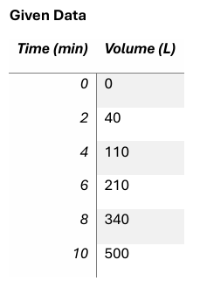
CASE STUDY 4: Water Tank Filling Rate Analysis

Scenario: A water tank is being filled, and sensors record the volume of water (in liters) over time (in minutes). Engineers want to determine:
- The rate at which water is entering the tank
- The total volume accumulated over time

Expected Outputs
- Table of flow rates (L/min)
- Integrated total volume
- Graphs
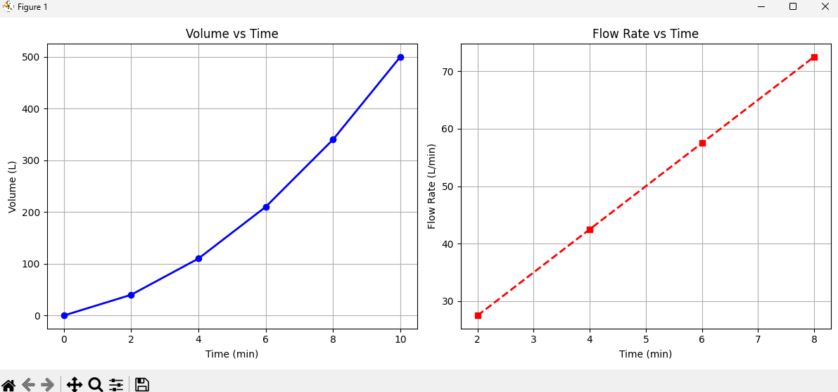

- Short explanation
- Is the flow rate constant?
No, the flow rate is not constant.
By applying the method of central differences, we can see that the flow rate ($Q$) changes significantly over the 10-minute interval. If the rate were constant, the values at 2, 4, 6, and 8 minutes would be identical. Instead, the calculations show a clear upward trend.

- When is the inflow fastest?
The inflow is fastest at the 8-minute mark.
According to the derived data points:
- 2 min: 27.5 L/min
- 4 min: 42.5 L/min
- 6 min: 57.5 L/min
- 8 min: 72.5 L/min
At this point, the filling rate reaches its peak value within the observed timeframe.

- Is the system linear or accelerating?
The system is accelerating.
The flow rate (which is the first derivative of volume with respect to time, dv/dt) is increasing over time. Because the speed of water entering the tank continues to rise, the total volume of water accumulated grows in a nonlinear fashion. Specifically, since the flow rate increases by exactly 15 L/min every 2 minutes, the system exhibits a constant positive acceleration in its filling rate.

